Come see the film
“The World According to Monsanto”
This enormously powerful documentary chronicles Monsanto’s race to spread genetically modified food and to take over food production throughout the world.

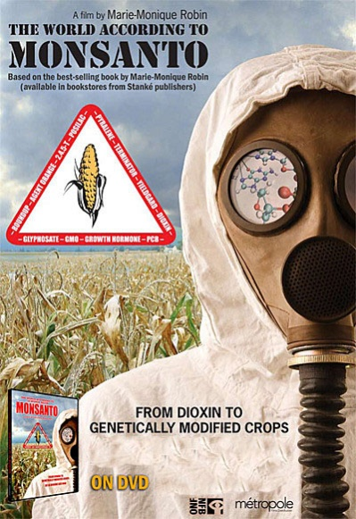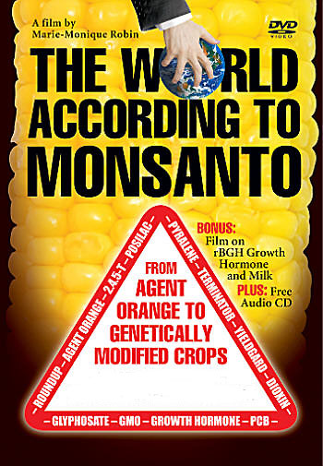

Monsanto has produced some of the most toxic products ever sold, including PCBs and Agent Orange. The company’s controversial past includes misleading reports, pressure tactics, collusion, and attempted corruption. Exposing secret documents with first-hand accounts by victims, scientists, and politicians, this widely praised film exposes why Monsanto’s frightening strategy profoundly threatens our health, environment, and economy.

Unitarian Universalist Society of Oneonta
12 Ford Ave. Oneonta, NY
Tuesday, January 24th at 7:00 p.m.
There will be discussion and refreshments. Informational materials will be available along with actions that can be taken to fight this threat.

Sponsored by the Unitarian Universalist Society’s Social Action Committee as part of UU Thoughtful Tuesdays.

